**---- RESILIENT IDENTITY CRIME DETECTION (KETAN, NEHA) DOCUMENT - CODE SUPPORT – EXPLINATION FOR CODE EXECUTION ----**

**Read file from user for testing (com.main.view-> Process1.java => line number 182 to 193 )**

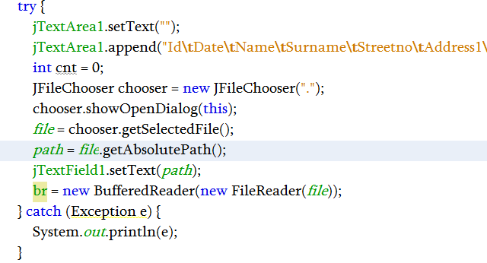

**Read file from user for testing (com.main.view-> Process1.java => line number 283 to 248 )**

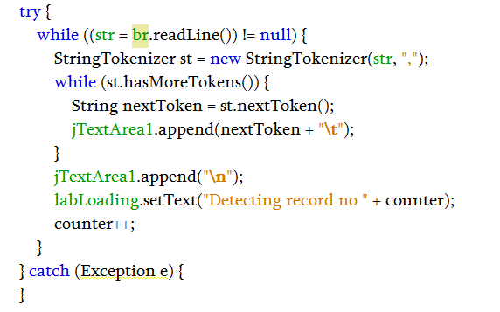

**Read file from user for testing (com.main.view-> Process1.java => line number 256 to 261 ) setting all the testing user data to java memory for further process**

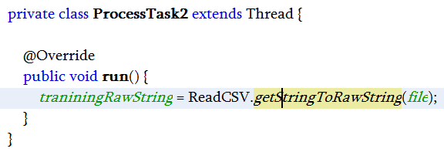

**:- Read file from user for testing (com.main.process -> ReadCSV.java => line number 83 to 90 ) setting all the testing user data to java memory for further process**

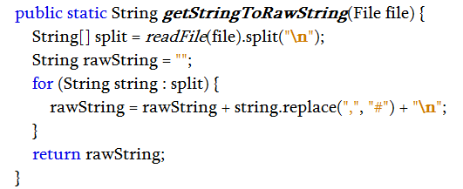

**Data filtration process (com.main.model) => DatasetTableModel.java Setting data to filter line no 18 – 21 then line 48 to 65 line number**

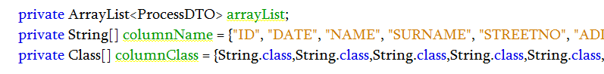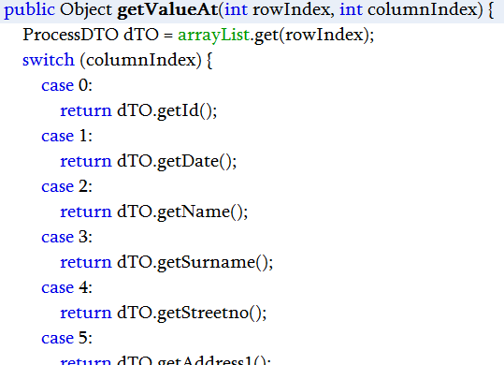

**com.main.process => ISimilarityCalculator.java (communal detection method )**

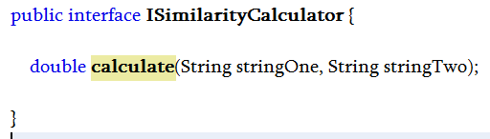

**com.main.process => IDistanceCalculator.java (spike detection method )**

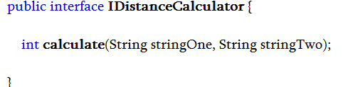

**package com.main.view => Process4.java (Main logic how spike and communal work together )**

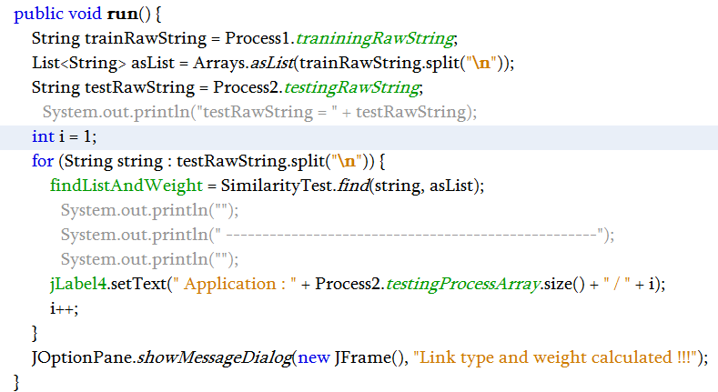

**package com.main.view => Process4.java (Main logic how spike and communal work together )**

**find by communal line no 57 – 63 /// return status list /// 1st white and black list**

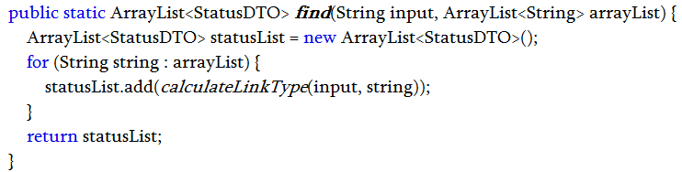

**Found by spike line number 65 -75 /// input new status list // final white and black list**

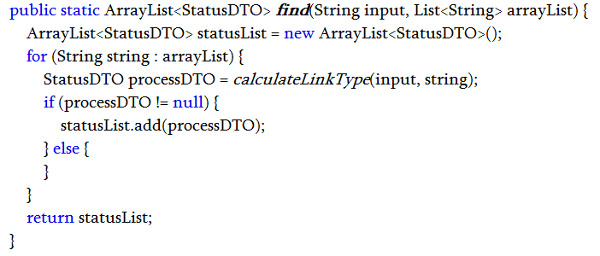

**Link type calculation for both communal and spike line no 57 - 63**

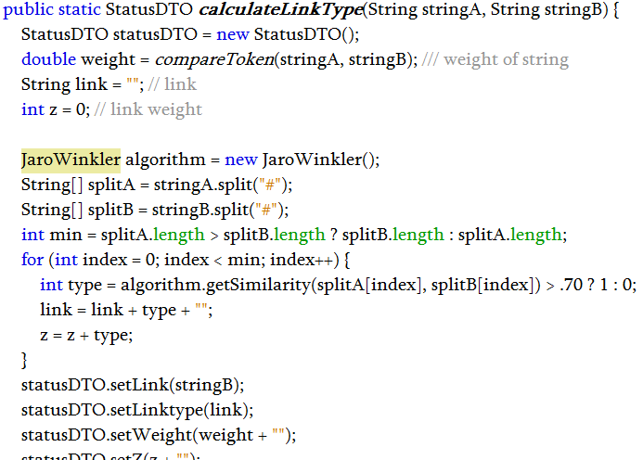

**Calculating score for each records 114 – 122/// finding score for comparison**

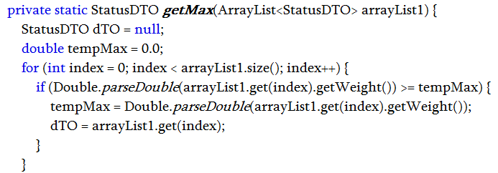

**Similarity for 2 tokan of individual spike and communal line no 76 – line 80 //**

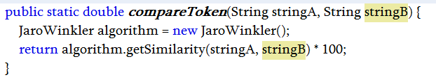

**com.main.process => DBConnection.java => line 19 – line 28 database connection code**

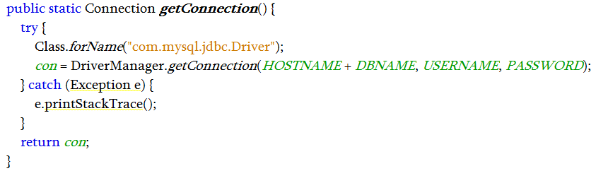

**com.main.graph => Knowage1.java => line 59 – line 73 Graph Generation code**

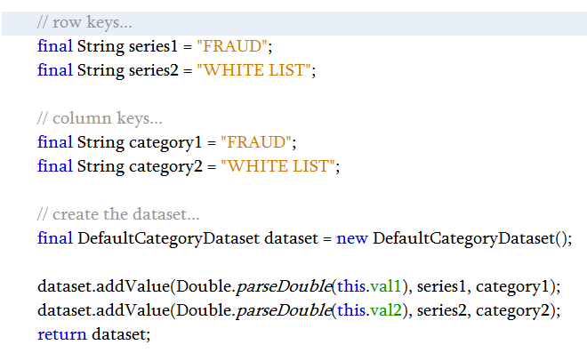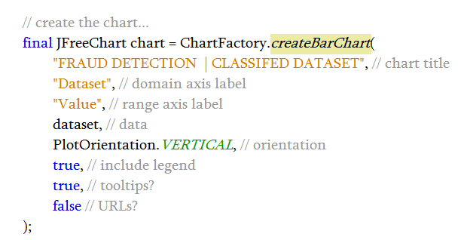

**com.main.view => Process4 => line 247 – line 265 => final white list creation**

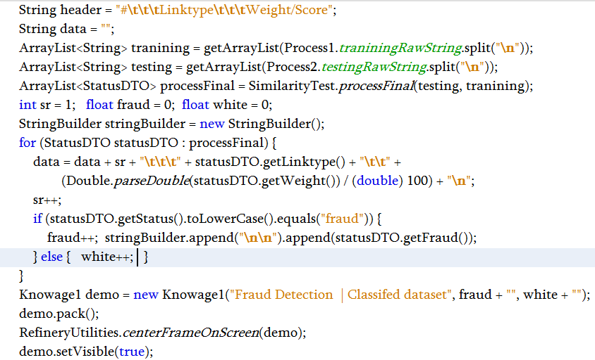

**Some extra and internal algo**

**com.main.process => how similarity test work => word by word => CharacterVectorUtils.java**

**input 2 DataStream** 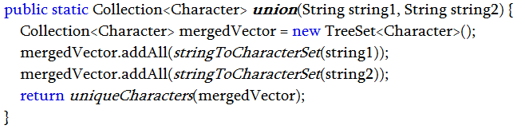

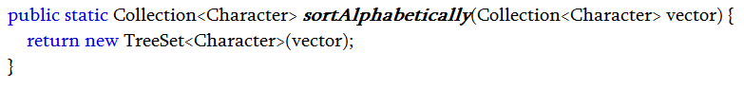

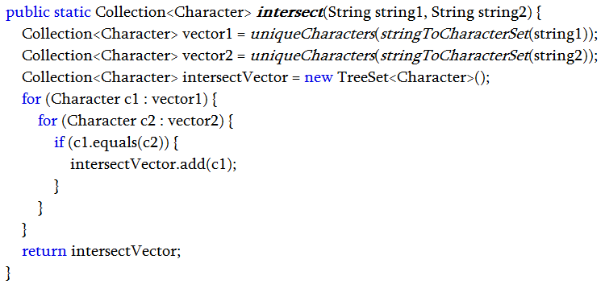

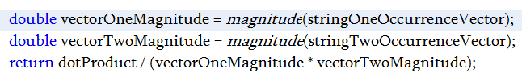

**Com.main.process (DamerauLevenshteinDistance.java) how we find pravin = Praveen line number 33 to line number 41**

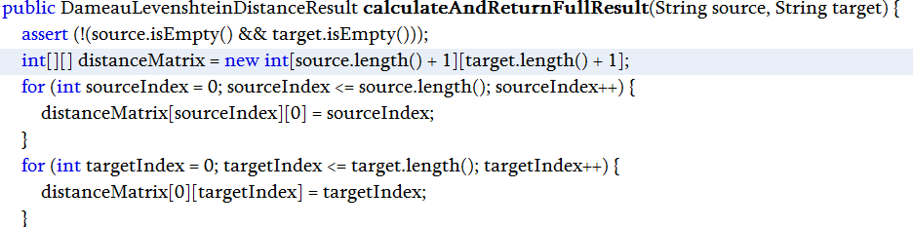

**Continue part => Line number 43 to line number 60**

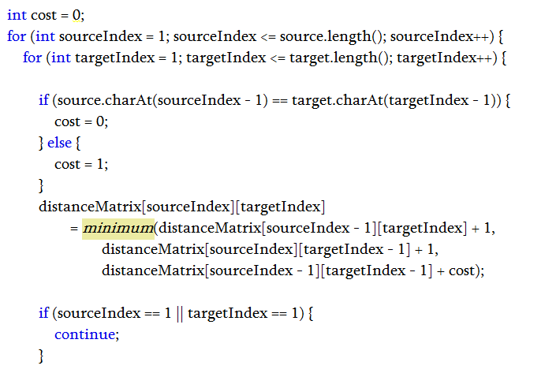

**Continue part => Line number 62 to line number 70**

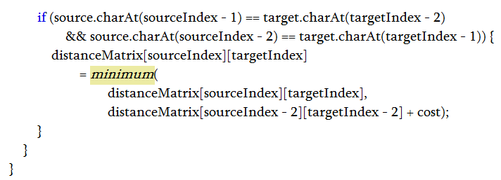

**THANK YOU, EEW TECHNOLOGY**